P3 策略：

Why的四个角度
个人：身体/心理
人际：对内/对外
经济
教育：对自己/对下一代

词汇：
身体：
Stretch muscles
Strengthen bones
Enhance immune system
Never suffer from insomnia
Shape my body
Lose weight/ shed pounds

心理：
Relax/unwind
Take my mind off things
Forget the pressure from exams
Put sb. in a good mood

人际：
Strengthen family bond/ties/friendship
Catch up with each other
Spend more quality time together

答题框架（一般说2-3个理由）
There are many reasons
For example / off the top of my head...
In addition,....
But I think the most important reason is that...

分类法
题目中出现people，可以按照：
年龄 性别 贫富 性格 职业 进行分类

五步法
起 承 转 例 合
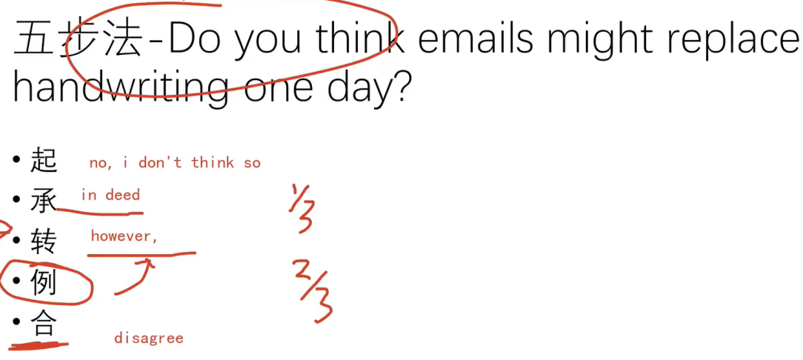

-
顺推法 原因加结果

措施法
政府 个人 家长 学校 公司

Do you think it is necessary to encourage people to compete with others in companies?

What are the contest commonly seen on TV programs?

Sports contest are commonly seen, such as football matches and basketball matches, In China, people go to CCTV Channel 5 to watch sports competitions, they streams real time games as well as recordings.

Singing contest is one of the contest that get popular recently on TV, it is a very good way for singers who just started their careers to be discovered by the public and develop their groups of followers.

What kinds of industries need competition?

Because the customers in these industries like to compare different products.
Customers can distinguish good products from bad products, when they find products of certain companies have an obvious advantage over the others. They will only buy that best product, which brings a large amount of revenues and sales to the winners. These companies need to keep challenge themselves and come up with better product to meet the demands of customers.

Do you think technology will harm children’s ability to concentrate?

Well, In my opinion, it totally depends on how they use them. Some children use technology to facilitate their studies, to get access to the abundant information on the Internet, while others only use them for entertainment, they get addicted to video games and watching youtube videos, those are the ones hurt by the development of technology, they lose their self control as well as their ability to concentrate.

